Isaac Hooge March 10 2018
Bitcoin:
The goal of this research is to learn how the bitcoin blockchain functions from a high level point of view to a low level technical overview. This research aims to understand the bitcoin specific implementation of the blockchain and how potential attacks are prevented and or enabled. From this research, I will implement aspects of the blockchain data structures in C code as a proof of my understanding.

Notes from the Bitcoin Whitepaper: https://bitcoin.org/bitcoin.pdf

Transactions:
a transaction consists of a digital signature.

This digital signature is a signed hash with the owners private key. The hash is a hash of the recipiants public key and the owners previous transaction. The owners digital signature can verified with the owners publikc key which exists in the owners previous trasnaction. (in public key cryptography traditionally the private key is used to decrypt the message and the public key to encrypt the message as seen in pgp, in bitcoin’s case, the private key is used to encrypt the hash and decrypted with the publically known public key, this allows the network to verify that the owner of these bitcoins has the intention of sending them to the specified recipiant (specified with there public key).)

Each transaction uses up all the owners bitcoin so that the specified amount is sent to the recipient and the change is returned to the owner all in one transaction.
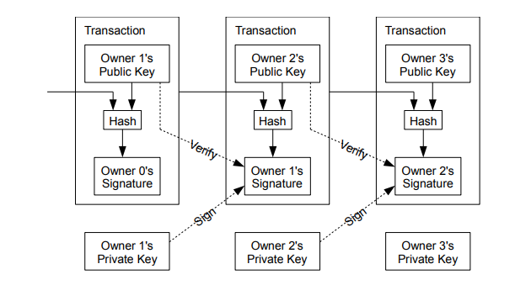
Source: https://bitcoin.org/bitcoin.pdf

BlockChain or Timestamp Server:
The blockchain prevents double spending which is to send two transaction and having them processed essentially creating money from thin air. The creation of the transactions does not prevent a user form digitally signing numerous tranactions to other recipiants and broadcasting these over the network. In order to prevent against double spending and to not have a middleman processing transactions, a public ledgar of transactions must be known to the network and a single agreed upon transaction history must be known to nodes on the network.

The blockchain consists of using timestamp hashes for each block of data. By the very nature of a cryptographic hash, if any data in the block is changed, the resulting hash is completely diffrerent, therefore by hashing the data of each block, the information in the block is proved to have existed in the block at the time of the hash (maintaining data integrity) . This timestamp server has each block timestamped via a hash. Each hash also consists of not only the data in the block but also the hash of the previous block. This forms a chain which enables the integrity of the information within the blocks and prevents a malicious attacker from modifying information within a block without the entire network knowing.

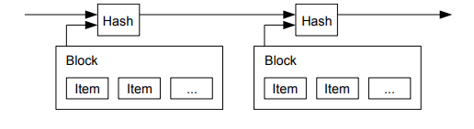
Source: https://bitcoin.org/bitcoin.pdf

Proof of Work:
The high level process of “mining” is as follows. Miners, using a SHA-256 hash, scan for a difficulty property where they look for a set number of 0 bits known as the difficulty. The more 0 bits in the hash prefix required to comply to the difficulty the harder it is to create the proof-of-work. For every 0 bit added to the difficulty the average work required increases exponentially e.g 2^(number of 0s). So miners scan a hash to comply with this difficulty level. This hash is generated from a number known as the nonce (which increments)until the hash satisfies the difficulty requirment. Once satisfying the difficulty, the hash is used in creating the next hash in the next block.
-the difficulty is adjusted every 2016 blocks and adjusts depending on how fast block are being mined.
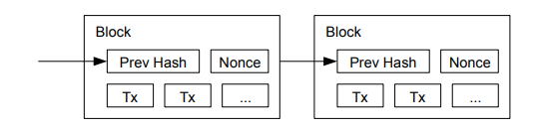
Source https://bitcoin.org/bitcoin.pdf
The structure of a block consists of a merkel tree. A merkel tree is essentially a binary tree where each node contains a hash. Each parent node consists of the hash of both sibling nodes. The merkel root is the root hash of all the sibling branches. In bitcoin, a transaction is hashed and added to these nodes at the leaves and the tree grows from tree leaves up to the merkel root. The merkel root or root hash is then hashed with the nonce (along with other data in the block header)and checked if it satisfies the proof of work difficulty. If this hash does comply then it is known as the block header hash and the next block in the chain incorporates this hash in forming the next block.
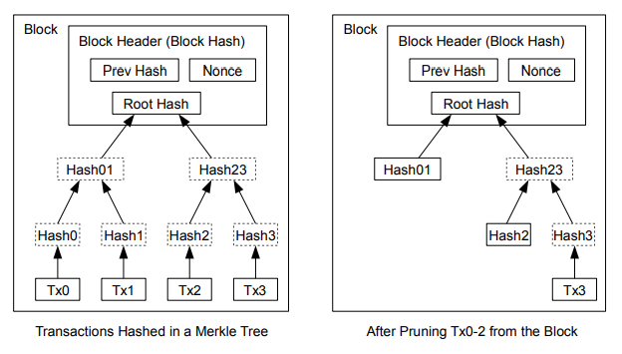
Source: https://bitcoin.org/bitcoin.pdf
The coinbase transaction as it is known is the first transaction in a block. A miner would add this transaction and have it sending bitcoin to themsleves when creating a block. This transaction is important as it rewards miners with bitcoin for there proof of work efforts. This transaction also adds new coins to the supply at a conistent and known rate (roughly every 10 minutes) .

The Network:
The network works as follow, each miner collects transactions into a block and begin the proof of work algorithm for the block. A miners block may differ from another miners block. Once a miner solves the proof of work it broadcasts its block to the network. Nodes on the network check if the block is valid and if non of the transaction have been already spent. They also check the proof of work via hashing the block header (which consists of the nonce, merkel root, and other info in the block header) for themselves and check if it complies with the specified network difficulty. A node then adds it to its copy of the blockchain by using the blocks header hash as part of the new header hash of the new block the miner begins weorking on. The largest chain is considered to have the most proof of work and therefore a miner accepts the longest chain as the correct one.

A fork in the blockchain occurs when two nodes broadcast different new blocks at the same time. These new blocks propogate through the network and are accepted by different groups of nodes. The fork ends when the next block is found as this represents the longest chain. The nodes who get a hold of both chains will hold both until the next block is found then discard the smaller chain. The nodes who receive both chains will work on the one they received first.

Attack:
A known vulnerability in the protocol of bitcoin is a 51 percent attack. This form of attack involves an attacker having over 51 percent of the hashing power of the network. With this computer power an attacker is able to fork the blockchain at some point where a transaction between the attacker and another party has occurred. The attacker with their computer power is able to privately mine on a malicious fork which differs from the other by instead a transaction back to the attacker rether than the recipient party. The attacker, having a large share of the hash power, would be able to outpace the blockchain being worked on by ‘honest’ bitcoin nodes. The attacker would then converge the malicious blockchain after the recipient party has 6 block confirmations after the transaction between the attacker and the party was mined. At this point since the malicious blockchain is larger than the honest chain, once the attacker broadcasts this blockchain, all the miners on the network would conisder the longer malicious chain as the most proof-of-worked chain. This would wipe the history of the transaction between the attacker and the recipient party off the blockchain. This attack is the only known vulnerability in the blockchain, an attacker would not be able to change the blockchain in any other way other then a transaction between himself and another party. A malicous alteration in any other way would be rejected by the bitcoin nodes as an alteration would interfer with the integrity of the hashes and or the exceptance criteria a legitimate transaction.

Source: https://bitcoin.org/bitcoin.pdf

Other Notes:
-blocks that are found but which don’t comply with the network difficulty will be rejected by nodes on the network
Source: https://en.bitcoin.it/wiki/Mining

-bitcoin uses Hashcash as a proof of work function for mining.
Hashcash is a proof-of-work function which attempts to prevent spam by requiring a proof-of-work on an action. The proof-of-work requires CPU time which mitigates against spam as iterating an action would require computer resources.

-the Hashcash algorithm uses hashes. A hash is a one way function that is computationaly difficult to invert. This is known as “the pre-image resistance property”. Brute force hash inversion running time has a order complexity of O(2^k), k being the size of the hash, which for bitcoin is SHA256 so k = 256 bits. Since the brute force inversion is so large compared to computing the hash, there is a large assymetry.

-hash cash goes by this formula: H(x)/2^(n-k) = 0; where n is the size of hash, k is the work factor or number of zeros needed at the beginning of the resulting hash in order to be a viable proof-of-work. For instance if k = 6 2^6 = 64 or an average of 64 tires before a resulting hash contains a prefix of 6 zeros.H(x)/ basically says that H(x) gives a hash of size n but remove n-k bits and only consider the first k bits and check if they are 0’s.

-hashcash is an proof-of-work algorithm which takes a string header appended with a nonce and hashes it in order to get a fixed amount of 0 bits in the prefix of the resulting hash. It is only solvable via brute force yet easily varifyable by simply preforming a single hash.

-in bitcoin the hashcash algorithm is modified with H(s,c)/2^(n-k) = 0 where s is the service string (in bitcoins case the merkel root) and c is the nonce counter. In Hashcash version 1 uses a random c start point so that if two workers get the same service string their work is not wasted on a duplicate proof-of-work. This is distinguished with the addition of x the random start: H(s,x,c)/2^(n-k) = 0. With bitcoin the addition of x in the algorithm is unnecessary as the coinbase transaction provides the extra randomness such that the service string is always unique. This is because the coinbase transaction has the details of the miners wallet address and other specific details of that users public key making the resulting merkel root completely different even if all the other transaction in the block remain equivalent. Therefore the nonce begins at the same starting poistion for every miner. But of course code changes could modify this feature.

-to provide extra security for the miner, the algorithm incorporates an additional nonce which is generated randomly. The random nonce is presumably added to the 0-start nonce and this one is incremented. This hides the amount of effort used in finding a proof of work for example no one can then see how many times if took you to find the block given the value of the nonce. Also if you find multiple successive blocks and if you change your receiving address and not the nonce, users can determine it was you who mined those blocks based on the consecutive values of the nonce.

-in bitcoin the proof of work algorithm uses two consecutive SHA-256 hashes. So it takes the string and appends it with the nonce and hashes the string twice before checking the bits.
Source: https://en.bitcoin.it/wiki/Hashcash

Bitcoin Hashcash:
The bitcoin hashcash works as follows:
The parameters of the hashcash algorithm include the service string, the nonce and a counter. The service string is a hash of the block header which consists of the block version field(4 Bytes), hash of previous block(32 Bytes), merkle root(32 Bytes), current time(in unix time in hex 4 Bytes) and the difficulty(4 Bytes). All the five fields listed are in hexidecimal format and concatinated in order before being hashed. After the block header is hashed it is then hashed again with the nonce(4 byte or 32 bit number) before it is checked against the difficulty. If the nonce wraps (go past 2^32) the extraNonce field located in the coinbase transaction is incremented changing the merkle root hash. The coinbase transaction is in the left most leaf node of the merkle tree.

[TODO NEXT]--not clear if nonce is concatinated to block header before first hash or second, or if there is two hashes need to check. Also go back and know which format is it in before hash hex? Also go over little and big endians and how they are before hashing.

Source: https://en.bitcoin.it/wiki/Block_hashing_algorithm
Source: https://pastebin.com/bW3fQA2a

